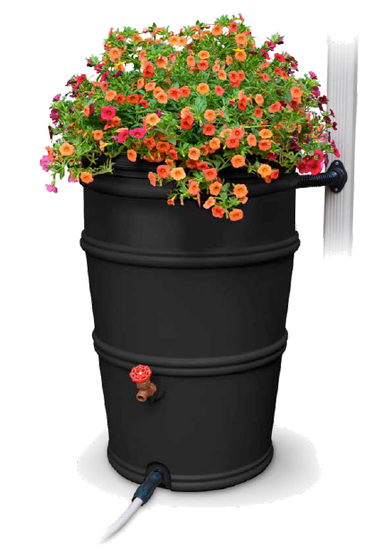
New Program Offers Low-Cost Rain Barrels to Local Residents and Businesses
Dane County and the Madison Area Municipal Stormwater Partnership (MAMSWaP) are now accepting orders for low-cost 50-gallon rain barrels. Rain barrels capture and contain rainwater from downspouts for use after the storm when it can seep back into the ground slowly. This reduces the amount of stormwater runoff that can carry pollutants down storm drains into our lakes, rivers and streams. Harvested water can be used later to water lawns, gardens, and potted plants helping to conserve water and save you money!
Dane County is selling 50 gallon rain barrels at a discounted rate of $74 (typically retails for ~$150). This program is open to all Dane County residents and businesses. If you live in a MAMSWaP community, you are eligible to apply for an additional $30 reimbursement. Rain barrels will be available for pickup at the Middleton Recycling Center and Deforest Yardwaste Collection Site during normal operating hours for those facilities.
For more information on how to order a rain barrel, and how to apply for available reimbursement programs, please visit: www.ripple-effects.com/rainbarrels. Your actions can have a Ripple Effect on our waters!

