## Clean Waters Start at Home: Low-Cost Rain Barrels for Sale

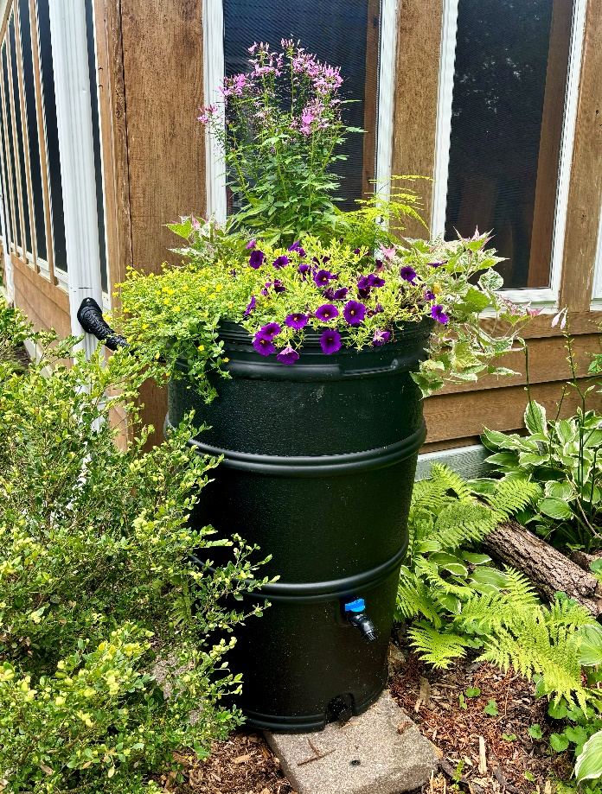Installing a rain barrel is a simple yet powerful way to help protect our waters. When rainwater flows off of roofs and onto the ground, it often picks up pollutants like fertilizers, oil, and debris which flows downstream to nearby waterways. Using a rain barrel helps slow down and control the flow of water, minimizing erosion and protecting aquatic habitats from sudden surges of dirty water. Be sure to use the harvested water during dry spells so your rain barrel is ready to collect water the next time it rains. This will help you conserve water while reducing your water bill.

Dane County and the Madison Area Municipal Stormwater Partnership (MAMSWaP) are selling 50-gallon rain barrels at a **discounted rate of $82**, limit four per household (typically retails for ~$130). This program is open to all Dane County residents. If you live in a MAMSWaP community, you are eligible to apply for an additional $30 reimbursement. Rain barrels will be available for pickup at the Middleton Recycling Center, Deforest Yard Waste Site, and Stoughton Public Works Facility.

For more information on how to order a rain barrel and how to apply for a reimbursement, please visit: [www.ripple-effects.com/rainbarrels](http://www.ripple-effects.com/rainbarrels). Your actions have a Ripple Effect on our waters!