Every Drop Counts: Low-Cost Rain Barrels for Sale
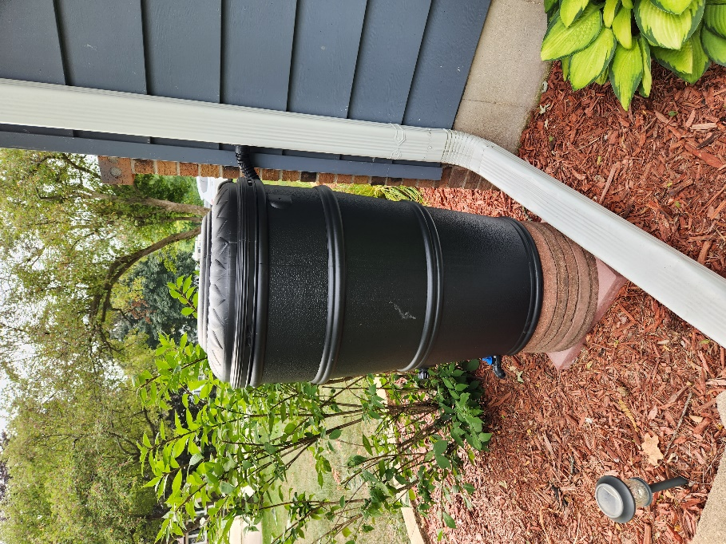
Rain barrels aren’t just a great way to capture rain to water your garden, but they can also help protect our waters. By redirecting roof runoff to a rain barrel, you are reducing the amount polluted runoff that washes into our local lakes, rivers, and streams through our storm sewer system. Be sure to use the harvested water during dry spells so your rain barrel is ready to collect water next time it rains. This will help you conserve water while reducing your water bill. Every drop counts!
Dane County and the Madison Area Municipal Stormwater Partnership (MAMSWaP) are selling 50-gallon rain barrels at a discounted rate of $78, limit four per household (typically retails for ~$130). This program is open to all Dane County residents. If you live in a MAMSWaP community, you are eligible to apply for an additional $30 reimbursement. Rain barrels will be available for pickup at the Middleton Recycling Center and Deforest Yardwaste Collection Site.
For more information on how to order a rain barrel, and how to apply for a reimbursement, please visit: www.ripple-effects.com/rainbarrels. Your actions have a Ripple Effect on our waters!

