# Chapter 9: Illicit Discharge Detection and Elimination

**Background Information**

An illicit discharge is any discharge to the City’s storm sewer system, or municipal separate storm sewer system (MS4), that is not composed entirely of storm water, with the exception of certain allowable discharges such as water from hydrant flushing or water used for firefighting operations. Illicit discharges are illegal, and Public Works staff perform illicit discharge detection and elimination (IDDE) field screening to protect the environment and meet regulatory requirements for the City’s MS4 Permit, available at: http://www.fitchburgwi.gov/233/Stormwater-Discharge-Permit.

IDDE entails visual observation of outfalls during dry weather to see if water is flowing when it is not raining outside. If water is observed, staff determine if the source is an allowable discharge (such as hydrant flushing) or an illegal discharge. If an illegal discharge is observed, staff work to identify the source of the discharge and follow up with the responsible parties.

***IDDE Inspections.*** The City has been divided into three zones, as shown in **Appendix E-1**. Each year, staff will conduct IDDE inspections in one zone (Zone 1 in 2019, Zone 2 in 2020, Zone 3 in 2021, etc.). Each outfall will be inspected at least once every three years, subject to staff availability and other competing priorities. After a baseline has been established, the City will review this plan and determine if certain areas warrant more or less frequent inspection.

IDDE inspections are conducted using a GIS app that displays a map of all stormwater outfalls in the City and allows the inspector to input data about each outfall. An example of the data collection form is included in **Figure** **9-1**. If flowing water is observed, staff will use the flow chart shown in **Figure 9-2** to determine appropriate next steps. If it is appropriate to take samples, the Standard Operating Procedure available in **Appendix E-2** will be used.

If illicit discharges are observed by the public, contact the City’s Environmental Engineer (Claudia Guy, 608-270-4262) to follow up on the illegal activity. Please provide date, time, and location of the release, suspected materials released, and identifying information for the responsible party, if available, such as a license plate number.

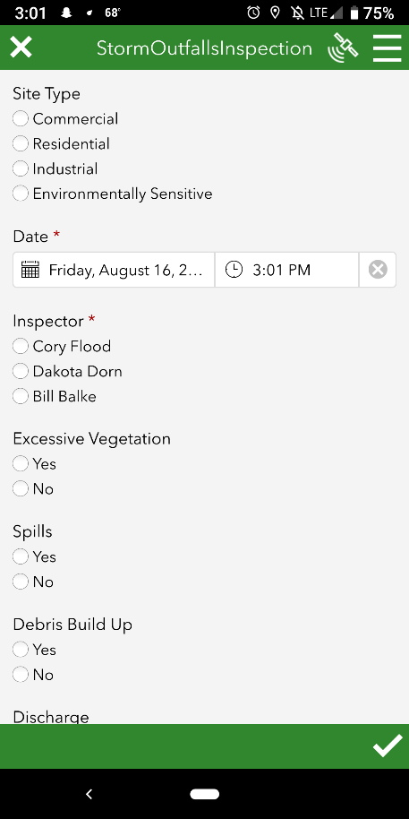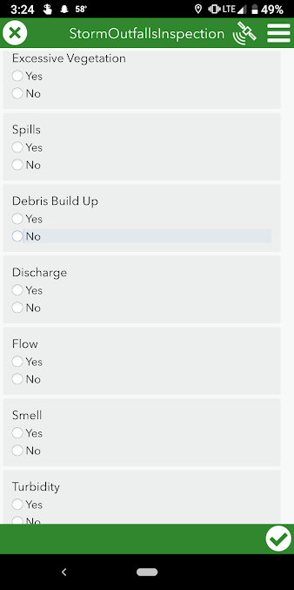

**Figure 9-1. Screen Shots of Outfall Inspection Form**

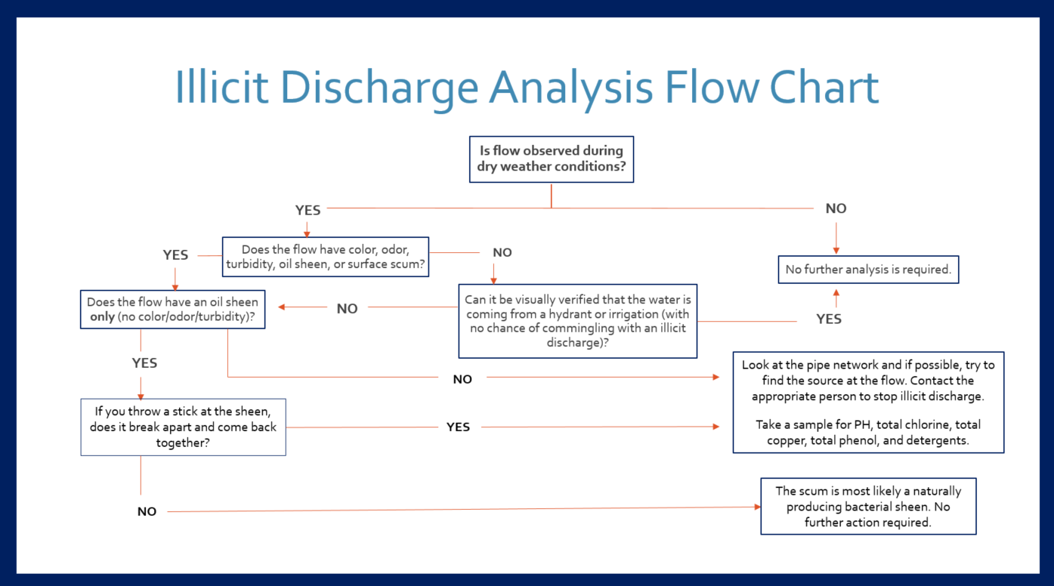

**Figure 9-2. Illicit Discharge Analysis Flow Chart**

**Appendix E-2. Standard Operating Procedure for Illicit Discharge, Detection, and Elimination Field Analysis Water Sampling, (Last updated: July 24, 2020)**

If flowing water is not determined to be an approved discharge (see **List 1** at the end of this document), first drive around the area that drains to the outfall to determine if you can find the source of the illicit discharge. If you cannot find the source, call your supervisor for assistance (270-4262). Then, follow these steps to test for detergents, ammonia, potassium, and fluoride.

1. Pick up sampling materials from City Hall at the locations specified below:
   1. Sampling Material Locations:
      1. Sample Bottles: City Hall Garage, behind the truck
         1. Public Health Lab Bottles
         2. State Lab of Hygiene Bottles
      2. Coolers: City Hall Garage, behind the truck
         1. City of Fitchburg Cooler
         2. State Lab of Hygiene Cooler
      3. Gloves: City Hall Garage, behind the truck
      4. Ice: purchased from a grocery store or gas station
         1. REMINDER: Bring the printed Tax Exempt Form along in order to make a tax-exempt purchase
2. Take water samples by collecting water into the appropriate bottle and carrying out the appropriate preservation technique (see **Table 1** and **Table 2** at the end of this document).
   1. Sampling Procedure
      1. Obtain all of the Sampling Materials from City Hall and buy ice from a store.
      2. Do not open the bottle cap until ready to take the sample
      3. Put on safety gloves.
      4. Carefully remove the bottle cap and collect flowing water into bottle.
      5. Replace bottle cap and immediately follow proper preservation technique (see **Table 1**).
      6. Repeat for every type of sample.
3. Water samples will be taken to two separate labs. Potassium, ammonia and fluoride samples will be taken to the Dane County Public Health Lab. Detergent water samples will be taken to the State Lab of Hygiene. The Dane County Public Health Lab does not test for detergents, and the City’s MS4 permit requires detergents testing, therefore that sample is taken to the State Lab of Hygiene.
4. Fill out the Dane County Public Health Lab bottle labels with the appropriate information
   1. Matrix: Other
   2. Sample Site: Location that sample was taken at
   3. Date & Time: Date and time sample was taken
   4. Preservation Technique: Specified in the **Table 1**, available at the end of this document
   5. Sampler: Your name
5. Fill out the State Lab of Hygiene bottle labels with the appropriate information
   1. Field ID: Stormwater
   2. Sample Location/Description: Illicit Discharge @ (location) for detergent testing
   3. Preservative Added: Ice
6. Fill out the “Illicit Discharge, Detection and Elimination Field Analysis Water Testing” sheet (attached below) and place with all Dane County Lab sample bottles.
   1. Testing Information: potassium, fluoride, ammonia
   2. Sampler Contact Information: Name, Phone, Email and City of Fitchburg information
7. Fill out the State Lab of Hygiene yellow “Water Test Request Form” (printed and located in State Lab of Hygiene red cooler)
   1. Report/Bill to: City of Fitchburg, 5520 Lacy Rd. 5371, your name and phone
   2. Check one report option: Email address (your email)
   3. Reason for test: Investigation (I)
   4. Well Information: N/A
   5. Collection Date: REQUIRED
   6. Sample Source: Other (PO)
   7. Sample Type: Storm Water (NP)
8. Once the samples have been collected, properly preserved, and labeled they should immediately be taken to the labs:
   1. See the **Table 1** below to find the hold time for each sample. The hold time is the allowable amount of time between taking and analyzing the sample in order for results to be valid. Fill out the **IDDE Field Analysis Water Testing Form** (available at the end of this document) to drop off with the samples).
   2. Public Health Madison & Dane County Lab
      1. Lab is located at:

Madison City County Building (CCB)

210 Martin Luther King Jr. Blvd., Room 507

Madison, WI 53703

* + 1. Sample Drop Off
       1. Normal Procedure: Drop them off in Room 507
       2. COVID-19 Procedure: A drop off must be arranged as the lab is locked. Call (608)-243-0357 to arrange.
    2. Lab hours of operations: Monday – Friday: 8:00 am – 4:30 pm
    3. Parking and Directions to Public Health
       1. Parking at the Government East Garage ramp would be the most reliable parking available:

Government East Garage

110 E Wilson St

Madison, WI 53703

* + - 1. There is also limited street parking on MLK Blvd.

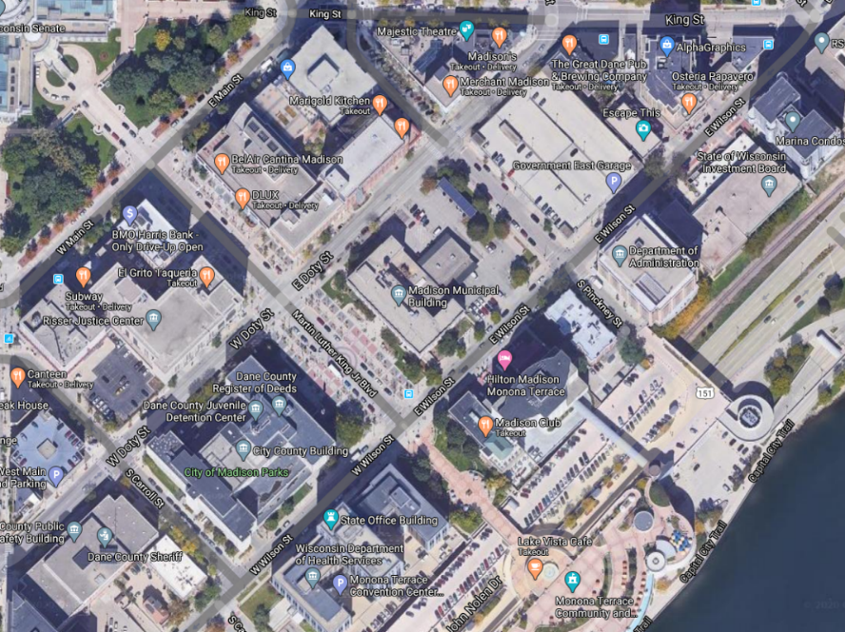

Park Here

Enter CCB Here

* 1. State Hygiene Lab
     1. Lab is located at:

2601 Agriculture Dr

Madison, WI 53718

* + 1. Sample Drop Off:
       1. Call Phil Manion (City of Fitchburg Utility Supervisor) to notify that samples are being dropped off - this step is IMPORTANT to ensure samples are NOT tested as municipal water
          1. Phone: (608)-729-1730
       2. Call the lab before dropping off samples (608)-224-6203
       3. Drive around to the back of the building
    2. Hours of Operation: Monday – Friday 7:45 am - 4:30 pm
    3. Parking and Directions
       1. Drive to the back driveway of the building

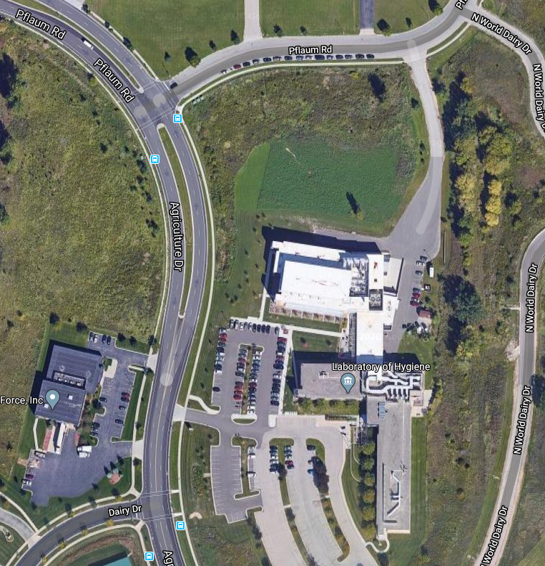

**Park Here**

1. Payment Information
   1. Public Health Lab
      1. Bring cash or check made out to the City Treasurer

City of Madison Treasurer

PO Box 2999

Madison, WI 53701

* + 1. If payment is not brought up front, the Public Health Lab will send an invoice for the water samples. Forward the invoice to your supervisor for payment.
  1. State Hygiene Lab
     1. Do NOT bring payment with samples
     2. The lab will send an invoice. Forward the invoice to your supervisor

1. Other Useful Information
   1. Location of all IDDE files: I:\Public Works\Engineering\Environmental\Stormwater\Storm Water\NR216 Permit\IDDE Field Screening Protocol
      1. Analyte Table: "I:\Public Works\Engineering\Environmental\Stormwater\Storm Water\NR216 Permit\IDDE Field Screening Protocol\Analyte Table.docx"
      2. Bottle Key: "I:\Public Works\Engineering\Environmental\Stormwater\Storm Water\NR216 Permit\IDDE Field Screening Protocol\Bottle Key.docx"
      3. Illicit Discharge, Detection and Elimination Field Analysis Water Testing Sheet: "I:\Public Works\Engineering\Environmental\Stormwater\Storm Water\NR216 Permit\IDDE Field Screening Protocol\IDDE Blank Test Info Sheet.docx"
      4. Public Health Lab Documents: I:\Public Works\Engineering\Environmental\Stormwater\Storm Water\NR216 Permit\IDDE Field Screening Protocol\Dane County Public Health Lab Documentation
   2. Public Health Lab Info
      1. Main Phone: (608)-266-4821
      2. Environmental Health Lab: (608)-243-0357
   3. State Lab of Hygiene Info
      1. Main Phone: (608)-224-6202
   4. [City MS4 Permit](http://www.fitchburgwi.gov/DocumentCenter/View/419/Permit-to-Discharge-July-19?bidId=)

**List 1. Approved Discharges from** [**City MS4 Permit**](http://www.fitchburgwi.gov/DocumentCenter/View/419/Permit-to-Discharge-July-19?bidId=) **Section 3.3.1 IDDE ordinance**

1. Water line flushing
2. Landscape irrigation
3. Diverted stream flows
4. Uncontaminated groundwater infiltration
5. Uncontaminated pumped groundwater
6. Discharges from potable water sources
7. Foundation drains
8. Air conditioning condensation
9. Irrigation water
10. Lawn watering
11. Individual residential car washing
12. Flows from riparian habitats and wetlands
13. Fire fighting
14. Discharged authorized under a WPDES permit

**Table 1. Analyte Table**

|  |  |  |  |  |  |
| --- | --- | --- | --- | --- | --- |
| **Analyte** | **Bottle** | **Preservation Technique** | **Hold Time** | **Cost (2020)** | **Lab** |
| Potassium | 250 mL HDPE rectangular, HNO3 in lab | None (HNO3 in bottle) | 6 months | $35 | Public Health |
| Ammonia | 250 mL HDPE round, H2SO4 in lab | Ice (0-6C) to 4 °C in cooler | 28 days | $25 | Public Health |
| Fluoride | 250 mL HDPE rectangular, 0-6C | None | 28 days | $20 | Public Health |
| Detergents | 32 oz (1 quart) | Ice in plastic bag around bottle in cooler | 48 hours | $26 | State Hygiene |

**Table 2. Bottle Key**

|  |  |  |
| --- | --- | --- |
| **Bottle** | **Picture** | **Cooler** |
| 200 mL IDEXX |  | City of Fitchburg |
| 250 mL HDPE round, H2SO4 in lab |  | City of Fitchburg |
| 250 mL HDPE rectangular, 0-6C |  | City of Fitchburg |
| 250 mL HDPE rectangular, HNO3 in lab |  | City of Fitchburg |
| 1 quart |  | Public Health Lab |

**Illicit Discharge, Detection and Elimination Field Analysis Water Testing Form**

These water samples were dropped off by the City of Fitchburg Public Works Department to be tested for suspected illicit discharge to the stormwater system.

**Testing Information**

Please test these samples for the following contaminants:

**______________________________________________________________________**

**______________________________________________________________________**

**Sampler Contact Information**

Name:

Phone:

Email:

**City of Fitchburg Information**

City Hall – Public Works Department

5520 Lacy Rd

Fitchburg, WI 53711

Phone: (608)-270-4200

Fax: (608)-270-4275

<https://www.fitchburgwi.gov/141/Public-Works>