

**Storm Water Pollution Prevention Plan**

***Prepared for the***

**Fitchburg Public Works Maintenance Facility**

**2373 S. Fish Hatchery Road**

**Fitchburg, WI 53711**

***Prepared by***

**City of Fitchburg Public Works Staff**

**December 2020**

Table of Contents

**Page**

1.0 INTRODUCTION 1

1.1 Purpose 1

1.2 Submittal, Review, and Amendment of the SWPPP Plan 1

1.3 Plan Organization 1

1.4 SPCC Plan Incorporated by Reference 2

1.5 Plan Distribution 2

2.0 Facility Location 4

3.0 Storm Water Pollution Prevention Team 7

4.0 Facility Description and Site Map 8

5.0 Good Housekeeping and Best Management Practices 11

5.1 Good Housekeeping 11

5.2 Structural BMPs 11

6.0 Maintenance Plan and Inspection Procedures 13

6.1 Annual Facility Site Compliance Inspection 13

7.0 Petroleum SPILLS PREVENTION AND RESPONSE 13

**List of Appendices**

APPENDIX A Records of Changes to the Plan and Annual Review

APPENDIX B Blank Inspection Form

APPENDIX C Annual Site Facility Compliance Inspection

**List of Figures**

**Page**

Figure 2-1. Map of the Fitchburg Public Works Maintenance Facility and Surrounding Area 4

Figure 2-2: Location of the Fitchburg Public Works Maintenance Facility on the MS4 Map 5

Figure 4-1. Fitchburg Public Works Maintenance Facility Site Map 8

Figure 4-2. Fitchburg Public Works Maintenance Facility Flow Path 9

**List of Tables**

**Page**

Table 3-1. Staff Contact Information 6

Table 5-1. Good Housekeeping Practices 10

Table 5-2. Structural Containment Measures 11

**Prepared by**

Claudia Guy, P.E., City of Fitchburg Environmental Engineer

Hannah Buscemi, City of Fitchburg Environmental Engineering Intern

**List of Acronyms**

|  |  |
| --- | --- |
| BMP | Best Management Practice |
| DNR | Department of Natural Resources (Wisconsin) |
| SPCC | Spill Prevention, Control, and Countermeasure |
| SWPPP  WPDES | Stormwater Pollution Prevention Plan  Wisconsin Pollutant Discharge Elimination System |
|  |  |
|  |  |
|  |  |
|  |  |
|  |  |

# INTRODUCTION

## Purpose

This document presents the SWPPP for the Fitchburg Public Works Maintenance Facility, located at 2373 S. Fish Hatchery Road in Fitchburg, Wisconsin. This document has been designed to comply with requirements published in the Individual Permit to Discharge under the Wisconsin Pollutant Discharge Elimination System (WPDES) Permit No. WI-S058416-4 (**“**MS4 Permit”). According to **MS4 Permit Section 3.6.3**,municipal garages, municipal storage areas, and other municipal facilities that have potential sources of storm water pollution located within the permitted area are required to prepare and implement a Storm Water Pollution Prevention Plan (SWPPP). To assist with matching the regulatory requirements to this plan, selected references to particular sections of theMS4 Permitare printed in **bold**.

The primary goal of the storm water permit program is to improve the quality of surface waters by reducing the amount of pollutants potentially contained in the storm water runoff. This SWPPP describes the facility and its operations, identifies potential sources of storm water pollution at the facility, describes best management practices (BMP) or pollution control measures to reduce the discharge of pollutants in storm water runoff, and provides for annual review of this SWPPP.

## Submittal, Review, and Amendment of the SWPPP Plan

According to **MS4 Permit** **Section 3.6.3**,the City of Fitchburg is obligated to update and maintain the SWPPP plan annually as needed. The City of Fitchburg Environmental Engineer is responsible for ensuring that the plan is reviewed and updated as required. When the plan is updated, it should be submitted to the DNR along with the annual report by March 31st of the following year. A record of changes to the plan and documentation of the annual (or more frequent) reviews are maintained in **Appendix A** to this plan.

## Plan Organization

This SWPPP has been organized to comply with the requirements listed in **MS4 Permit, Section 3.6.3.a**. The following sections are included in this plan:

* **Section 1.0** contains an introduction to the plan and a description of the facility, including the physical location of the facility with a key corresponding to the location on the storm sewer system map **(MS4 Permit, Section 3.6.3.a(1))**;
* **Section 2.0** contains contact information for the individuals with overall responsibility for the facility and the SWPPP **(MS4 Permit, Section 3.6.3.a(2))**;
* **Section 3.0** contains a map of the facility which includes: the locations and descriptions of activities and storage areas, drainage patterns, potential sources of contamination, discharge point locations, nearby receiving waters, and identification of connections to the municipal separate storm sewer system **(MS4 Permit, Section 3.6.3.a(3))**;
* **Section 4.0** contains a description of procedures, good housekeeping activities, and BMPs **(MS4 Permit, Section 3.6.3.a(4))**;
* **Section 5.0** contains contamination maintenance plan with inspection procedures and schedule to identify deficiencies, necessary improvements, and/or repairs, assess effectiveness, and address new or unaddressed potential sources of stormwater contamination **(MS4 Permit, Section 3.6.3.a(5))**; and
* **Section 6.0** contains spills prevention and response standard operating procedures **(MS4 Permit, Section 3.6.3.a(6)).**

The plan also contains appendices with supplemental information. These appendices include:

* Appendix A: Record of Changes to the Plan and Annual Review;
* Appendix B: Blank Annual Inspection Form;
* Appendix C: Annual Inspection Records.

## SPCC Plan Incorporated by Reference

The PW Maintenance Facility Spill Prevention, Control, and Countermeasure (SPCC) Plan is incorporated by reference. Please refer to the SPCC Plan for details on petroleum storage.

## Plan Distribution

The following table shows the distribution of this plan.

|  |  |
| --- | --- |
|  | **Copy No.** |
| Director of Public Works | **1** |
| Environmental Engineer | **2** |
| Parks and Forestry Maintenance Supervisor | **3** |
| Streets Supervisor | **4** |

# Facility Location

As discussed in **Section** **3.6.3.a(1)** of the MS4 Permit, the SWPP should include a description of the physical location of the facility with a key corresponding to the location on the storm sewer system map. The Fitchburg Public Works Maintenance Facility (or “PW Maintenance Facility”) is located at 2373 S. Fish Hatchery Road in Fitchburg, Wisconsin. The facility is located about 1,000 feet north of the intersection of S. Fish Hatchery Rd and Whalen Rd and approximately 1.25 miles northwest of a branch of Murphy Creek. It is bordered on the west by agricultural land, on the south by private residences, and on the north by a small veteran’s memorial park, as well as an American Transmission Company power station.

**Figure 2-1** provides the location of the PW Maintenance Facility, and **Figure 2-2** shows the location on the MS4 storm sewer map.

**Figure 2-1. Map of the Fitchburg Public Works Maintenance Facility and Surrounding Area**

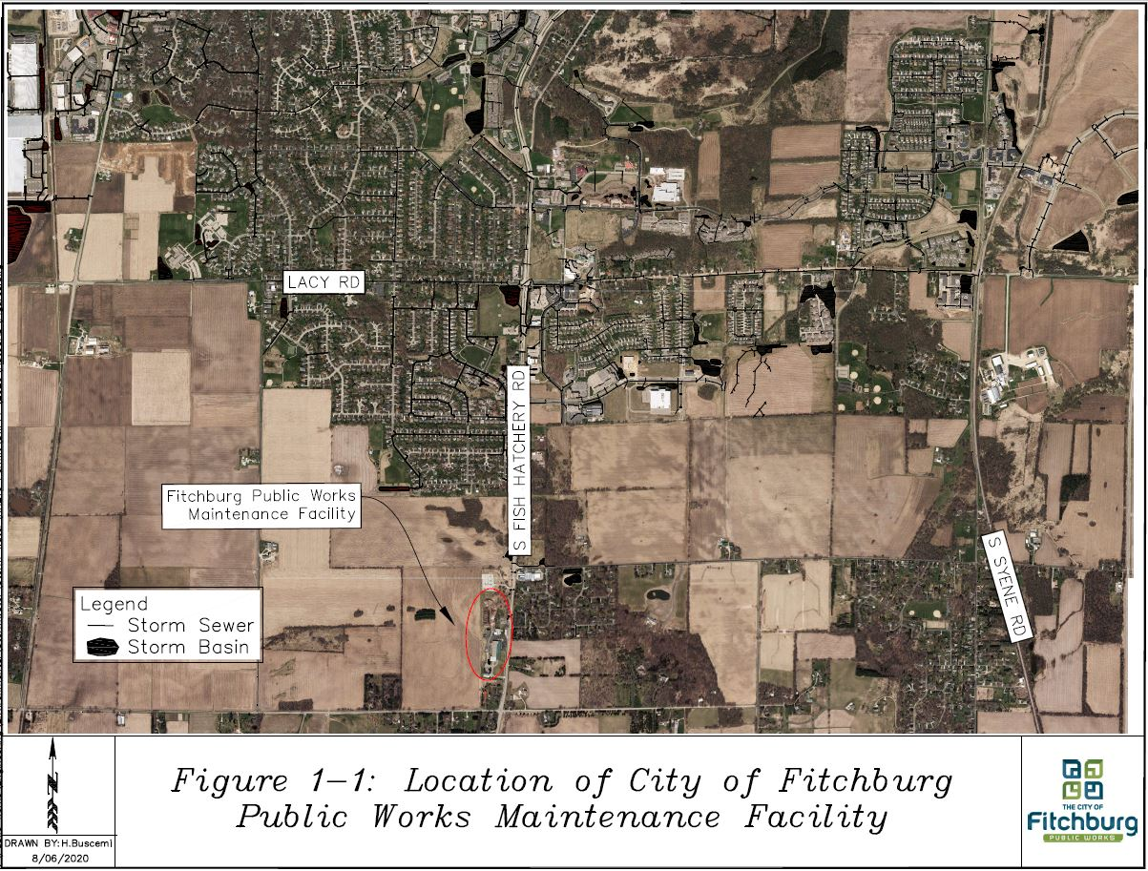

**Figure 2-2: Location of the Fitchburg Public Works Maintenance Facility on the MS4 Map**

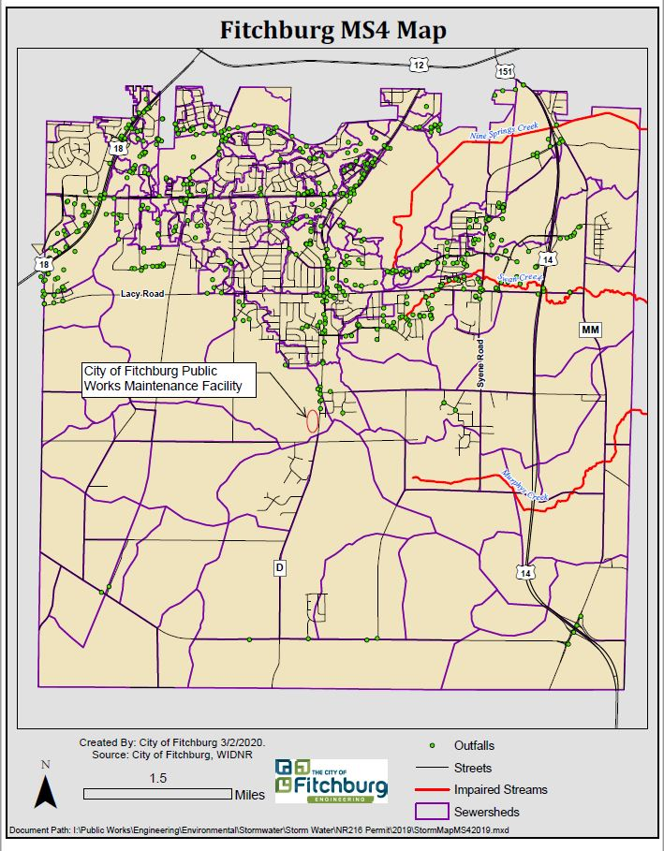

# Storm Water Pollution Prevention Team

According to **Section 3.6.3.a(2)** of the MS4 Permit, contact information for the individual(s) with overall responsibility for the facility should be identified in the SWPPP. The members of the team and their responsibilities, which include implementing, maintaining, record keeping, submitting reports, conducting inspections, employee training, and conducting the annual plan review (and revision, as needed), are identified in **Table 3-1**, below.

###### Table 3-1. Staff Contact Information

|  |  |  |
| --- | --- | --- |
| **Name and Tile** | **Contact Information** | **Responsibility** |
| Bill Balke  Director of Public Works | 608-270-4264  [Bill.balke@fitchburgwi.gov](mailto:Bill.balke@fitchburgwi.gov) | Management approval of SWPPP |
| Claudia Guy  Environmental Engineer | 608-270-4262  [Claudia.guy@fitchburgwi.gov](mailto:Claudia.guy@fitchburgwi.gov) | SWPPP preparation and annual updates, plan revision submittals to DNR (as needed), and employee training |
| Johren Frydenlund  Parks and Forestry Maintenance Supervisor | 608-729-1750  [Johren.frydenlund@fitchburgwi.gov](mailto:Johren.frydenlund@fitchburgwi.gov) | Implementing, maintaining, conducting inspections, and recordkeeping |
| Mark Hodel  Streets Supervisor | 608-729-1720  [Mark.hodel@fitchburgwi.gov](mailto:Mark.hodel@fitchburgwi.gov) | Implementing, maintaining, conducting inspections, and recordkeeping |

# Facility Description and Site Map

The facility includes a large, centrally-located building that houses public works offices and a large open indoor area to store and maintain vehicles and equipment. Southwest of that building is the Fitchburg Recycling Drop-Off site, where residents can drop off recycling at an unstaffed facility. The Recycling Drop-Off Site includes several dumpsters to collect recyclables (including polystyrene and cardboard), a yard waste collection area, and an area where compost is piled for residents’ use. A storage building is located south of the Drop-Off site. The northern portion of the property contains a salt shed, two additional storage buildings, and an outdoor composting / storage yard. The property also contains a grassy swale and detention pond along the western border, a parking lot and connecting roads. This facility is surrounded by rural, residential, and agricultural areas.

As required by **Section 3.6.3.a(3)i, Section 3.6.3.a(3)ii** and **Section 3.6.3.a(3)iii** of the MS4 Permit**, Figure 4-1** shows the layout of the PW Maintenance Facility, the locations and descriptions of major activities and storage areas, potential sources of stormwater contamination, drainage patterns, and discharge points. The following potential sources of stormwater contamination have been identified:

* The compost and storage yard area,
* The area outside of the salt shed where salt unloading occurs,
* The Recycling Drop-Off Site, and
* The re-fueling station.

Please note that the re-fueling station is discussed in the facility’s SPCC Plan, which is incorporated by reference.

**Figure 3-2** identifies nearby receiving kettles and nearby public storm sewer, as required in **Section 3.6.3.a(3)iii** and **Section 3.6.3.a(3)iv** of the MS4 Permit. All surface water runoff from the facility is either conveyed via overland flow or open ditches to a holding pond in the northwest corner of the site or a holding pond to the north of the storage yard. During rain events, these holding ponds may overtop and water would travel north via overland flow to the closed depression. Under normal conditions, water stays in the closed depression or holding ponds and eventually infiltrates into the ground. During extreme rain events, water from the closed depression may get high enough to flow east across S. Fish Hatchery Road (via a culvert), eventually reaching the ponds at Hillside Heights, which are also closed depressions.

**Figure 4-1. Fitchburg Public Works Maintenance Facility Site Map**

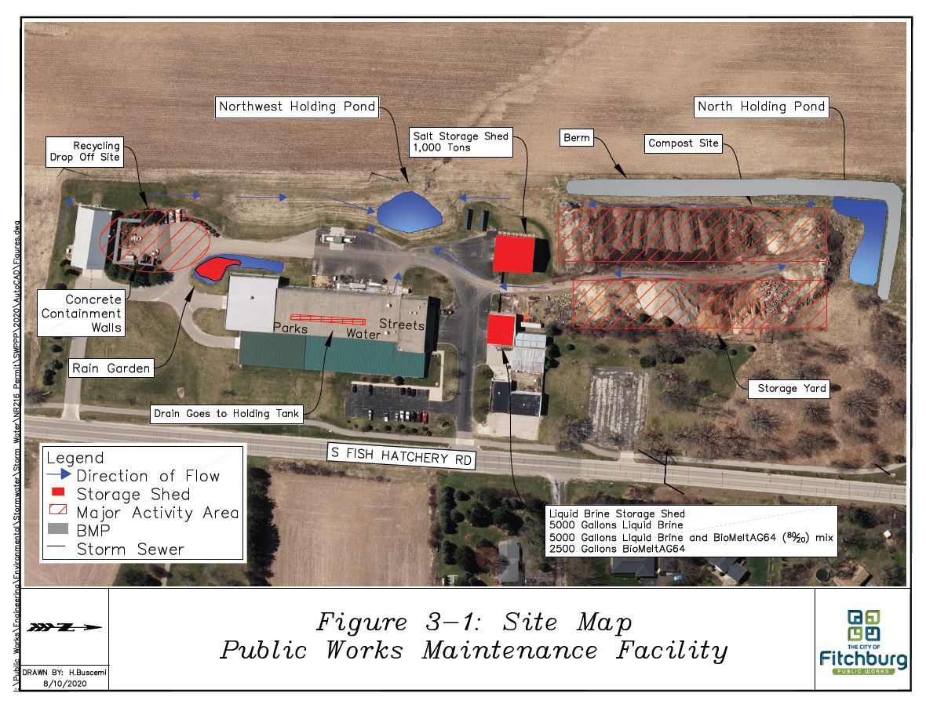

**Figure 4-2. Fitchburg Public Works Maintenance Facility Flow Path**

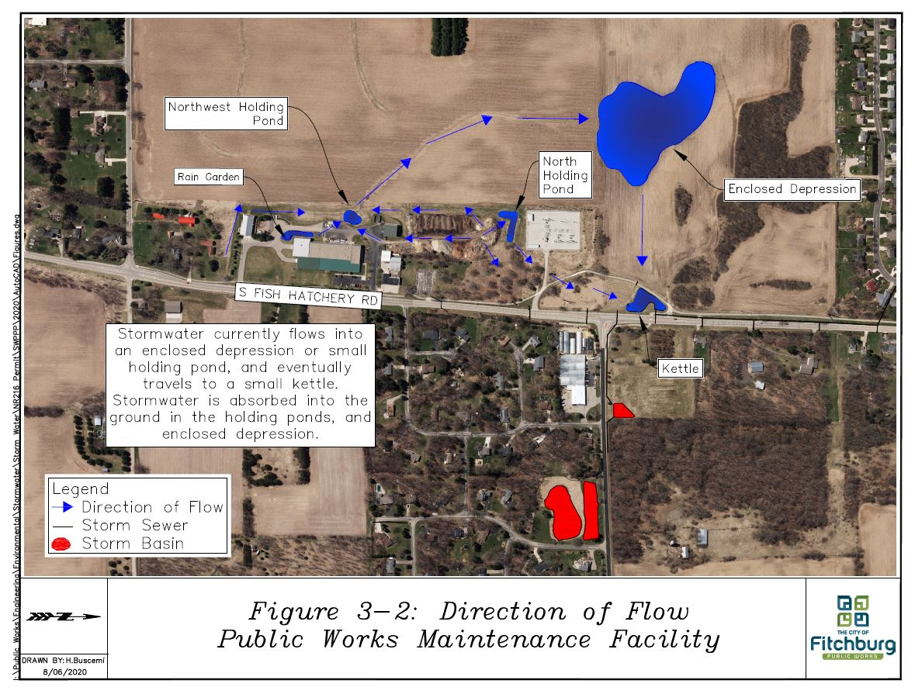

# Good Housekeeping and Best Management Practices

This section includes a description of procedures, good housekeeping activities, and any BMPs installed to reduce or eliminate stormwater contamination, as required by **Section 3.6.3.a(4)** of the MS4 Permit.

## Good Housekeeping

Practices in this section are implemented in order to maintain a clean and orderly work environment and to reduce the likelihood that materials will come into contact with the stormwater.

**Table 5-1** describes the practices included in the good housekeeping routine.

###### Table 5-1. Good Housekeeping Practices

|  |  |  |
| --- | --- | --- |
| **Area** | **Task** | **Frequency** |
| Vehicle Maintenance Shop | Floor sweeping | Weekly |
| Storage Garage | Floor sweeping | Weekly |
| Outdoor Spaces | Sweep or clean up spilled materials (including salt, brine, or any other material) | Expeditiously on an as needed basis |
| Outdoor Spaces | Pick up litter (especially near the Recycling Drop-off Site) | Expeditiously on an as needed basis |

## Structural BMPs

Structural control measures, or BMPs, are physical features installed to prevent stormwater pollution. BMPs pertaining to oil and fuel (such as secondary containment and location of spill response materials) can be found in the SPCC Plan. Other structural BMPs are listed in **Table 5-2**, and the location of these measures can be found in **Figure 4-1**.

###### Table 5-2. Structural Containment Measures

|  |  |  |
| --- | --- | --- |
| **Structural Control Measure** | **Area** | **Material** |
| Northwest holding pond | Southwest of Salt Shed | Any contaminant remaining in runoff |
| North holding pond | North of Storage Yard | Any contaminant remaining in runoff |
| Rain garden | Southwest of Main Central Building | Runoff from the storage garage roof and grassy area to the east |
| Lighting in key areas for spill detection | Throughout PW Maintenance Facility | Any contaminant potentially entering runoff |
| Paved areas throughout facility to prevent leaching into ground water and aid in spill response | Throughout PW Maintenance Facility | Any contaminant potentially entering runoff |
| Concrete containment walls | Recycling Drop-Off | Around yard waste, compost, and woodchips |

Areas prone to soil erosion shall be protected, and the soil kept out of the storm water discharge. The storage yard stock piles have exposed sediment which has the potential to run off to the outlet of the property. A berm was constructed along the north and northwest property line of the property. It acts to contain runoff from the compost area on the property. The elevated berm creates a chance for infiltration before water flows south or north to leave the facility. The gravel road through the storage yard is highly compacted to avoid erosion of the road, and prevent tracking from vehicles entering and exiting. The remaining areas traveled by vehicles on the site are paved. The paved travel areas prevent tracking of sediment off the facility. There are gabion stones installed at the northwest discharge point for the facility. The gabion stones act to slow the flow of the runoff and remove suspended sediment.

# Maintenance Plan and Inspection Procedures

According to **Section 3.6.3.a(5)** of the MS4 Permit, the SWPPP shall include a maintenance plan with inspection procedures and schedule for each facility to identify deficiencies, necessary improvements and/or repairs, assess effectiveness, and address new or unaddressed potential sources of stormwater contamination. These items are discussed in this section.

## Annual Facility Site Compliance Inspection

The Environmental Engineer and Streets Supervisor shall make an annual inspection to evaluate the effectiveness of this SWPPP. The inspection shall be adequate to verify that the site drainage conditions and potential pollution sources identified in the SWPPP remain accurate, and that the BMPs prescribed in the SWPPP are being implemented properly and effectively maintained. A sample Annual Facility Site Compliance Inspection form is attached in **Appendix B**.

# Petroleum SPILLS PREVENTION AND RESPONSE

According to **Section 3.6.3.a(5)** of the MS4 Permit, the SWPPP should include spill prevention and response standard operating procedures. Please refer to the PW Maintenance Facility SPCC Plan, which is incorporated by reference, for these procedures.

**Appendix A**

**Record of Changes to the Plan and Annual Review**

**Appendix A. Record of Changes to the Plan and Annual Review**

This SWPPP plan shall be reviewed and / or amended, if necessary, whenever the following conditions are met:

1. Annual Review
2. Applicable regulations are revised.
3. The facility changes—in its design, construction, operation, maintenance, or other circumstances—in a way that materially increases the potential for stormwater contamination.

**Record of Changes to the Plan**

|  |  |  |
| --- | --- | --- |
| **Date** | **Changes Performed by** | **Description of Change(s)** |
| December 2020 | Claudia Guy | Initial Issuance of Plan |
|  |  |  |
|  |  |  |
|  |  |  |
|  |  |  |
|  |  |  |
|  |  |  |
|  |  |  |
|  |  |  |
|  |  |  |

**Appendix B**

**Blank Inspection Form**

**Inspection Procedures**

This appendix contains the procedures to be used for inspecting the facility annually. The purpose of this inspection and reporting procedure is to ensure the SWPPP is effectively preventing contamination of the stormwater. An example form for the annual facility site compliance inspection is included.

**Responsibilities**

The Environmental Engineer will ensure that the annual inspection associated with this plan is performed.

**Recordkeeping**

All inspection records should be maintained in the Environmental Engineer’s copy of the SWPPP in Appendix D for at least five years.

**Inspection Frequency**

Will be performed once per year.

**Annual Facility Site Compliance Inspection Form**

**Date**: **Inspector** **Signature**:

**Instructions**: Answer the questions below with a brief explanation in each box. A response of “No” indicates a further explanation and revision to the plan. Complete once per year to evaluate the effectiveness of the SWPPP.

|  |  |
| --- | --- |
| **Facility:** |  |
| **1. Are the site drainage conditions accurately represented in the SWPPP? Explain:** | |
|  | |
| **2. Are the potential pollution sources identified in the SWPPP accurate? Explain:** | |
|  | |
| **3. Are the BMPs being implemented, operated, and maintained adequately? Explain:** | |
|  | |
| **4. Other major observations related to the effectiveness of the SWPPP:** | |
|  | |
| **5. What revisions to the SWPPP are required:** | |
|  | |
| **6. Personnel completing report and date:** |  |

**Appendix C**

**Annual Facility Site Compliance Inspection Records**

This section is reserved for records and documents generated by the City of Fitchburg

