Enviroscape Model Activity
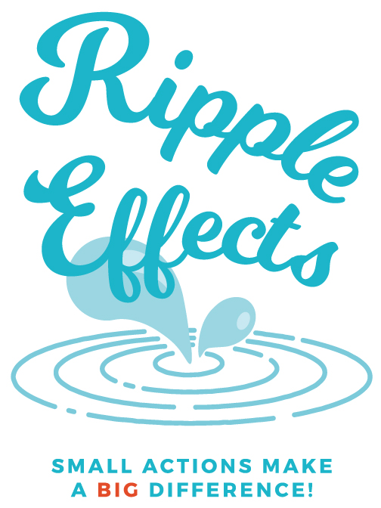
Intro Questions
- What is a watershed? A watershed is an area of land that drains into a particular body of
water (lake, river, stream). All the rain the falls within the boundaries of that area that
doesn’t soak into the ground will eventually end up flowing to that water body either over land or through storm drains/sewers.
- What watershed are we in right now? Nice to have maps to refer to.
- Where do you think this watershed drains to? Start local, but continue to get bigger until you get to a very large body of water (ex., Lake Mendota, Madison Chain, Yahara R., Rock R. (WI/IL), Mississippi R, Gulf of Mexico)
- What watershed do you live in?
- What happens to the rain after in falls near your home? Where does it go?
“We’re going to pretend this is _____watershed. Does it look kind of like the area around __________? “ Point out the neighborhood, golf course, farm, water, industry and new construction and try and connect these features to areas your audience recognizes within your watershed. As you point out different features ask the kids probing questions “Ever notice how golf courses are always green, even during a drought? How do they do that?” or “Ever notice rainbows on the pavement during a storm? What causes that?” Once they answer the question have them shake some of the pollutant on the land.
Green sprinkles – Fertilizer- lawn, golf course, farm
Cocoa- soil- construction site, farm with exposed fields, road construction
Red sprinkles- pesticides/herbicides- lawn, golf course, farm
Chocolate Syrup- oil/gas- road, parking lot, driveways
Brown sprinkles- pet waste- lawn
Yellow Sprinkles- salt- roads, driveways, parking lots
Oatmeal- leaves- road near driveway

“Now what happens to all this stuff when it rains?” Have kids help make it rain by spraying the spray bottle over the whole area. Have them go crazy, the more it rains the more exciting it is. Once runoff starts to drain into the rivers, lakes ask them what’s happening. Remind them that the rain off their property drains to a local river or lake (even water that goes down the storm drain!). Let them know that the water that goes into the storm drain doesn’t get treated like water that goes down the shower, sink or toilet. Ask them if they’d like to drink or swim in water that looks like that. How do you think the animals and plants that live in the water feel?
Follow up with ideas on what they can do to keep the water clean for all that use it including humans and the animals and plants that call it home. Visit www.ripple-effects.com for more information.
Best Management Practices
-reduce the amount of inpervious surfaces (pavement) or turf grass and replace with plant/gardens that help water to soak into the ground rather than runoff into storm drains.
-more buffers, raingardens, native plants to filter the water and keep it where it lands
-rain barrels
-erosion control-straw, erosion control mats/tubes, get seed/plants down ASAP- keep soil in it’s place
-clean up after pets
-keep leaves out of streets (prevent leaf tea)
-restore wetland (slow flow, filter)
-alternative farming practices- rotate crops, contour plowing, buffer strips, cover crops, manure management

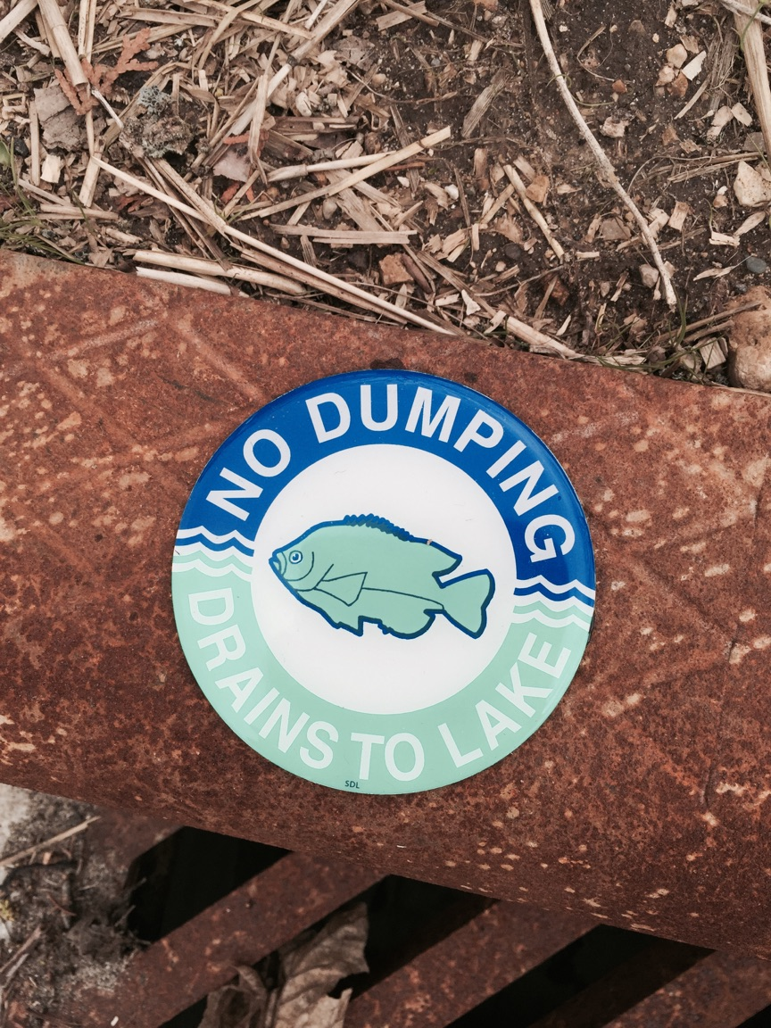
Follow Up Activity- Storm Drain Marking

Let others know that stormwater runoff that flows down the storm drain doesn’t get treated and ends up in our lakes/rivers by marking storm drains in your neighborhood “No Dumping Drains to Lake/River”. For more information visit:
http://www.ripple-effects.com/documents/world%20water%20day/Storm%20Drain%20Marking%20Flyer%20NEW.pdf

