**2025 Wisconsin Stormwater Week- MAMSWaP Social Media Tools and Sample Schedule**

**Start promoting Dane County events- Sept. 1st-10th**

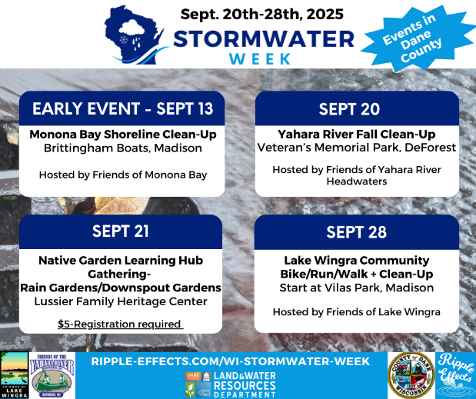

WI Stormwater Week is almost here! Join one of the upcoming clean up events here in Dane County or get some tips and tricks on how to start a rain garden or downspout garden at the next Native Garden Learning Hub Gathering. Small actions can make a big difference! *#WIStormwaterWeek #WIRippleEffects*

Learn more at: [*www.ripple-effects.com/wi-stormwater-week*](http://www.ripple-effects.com/wi-stormwater-week)

Can’t attend an event during WI Stormwater Week? Get a jump start by helping out with the Friends of Monona Bay Monthly Clean Up Event on the 13th. Walk the shoreline or jump in a canoe to keep Lake Monona clean. *#WIStormwaterWeek #WIRippleEffects*

Learn more at: [*www.ripple-effects.com/wi-stormwater-week*](http://www.ripple-effects.com/wi-stormwater-week)

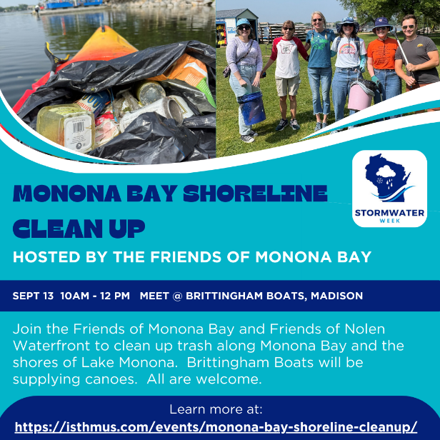

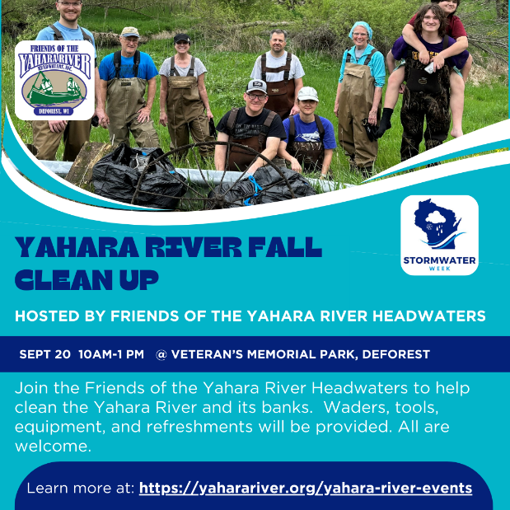

Kick off WI Stormwater Week by helping the Friends of the Yahara River Headwaters with a fall river clean up. Clean ups are a fun way to make a difference and meet some new friends. *#WIStormwaterWeek #WIRippleEffects*

Learn more at: [*www.ripple-effects.com/wi-stormwater-week*](http://www.ripple-effects.com/wi-stormwater-week)

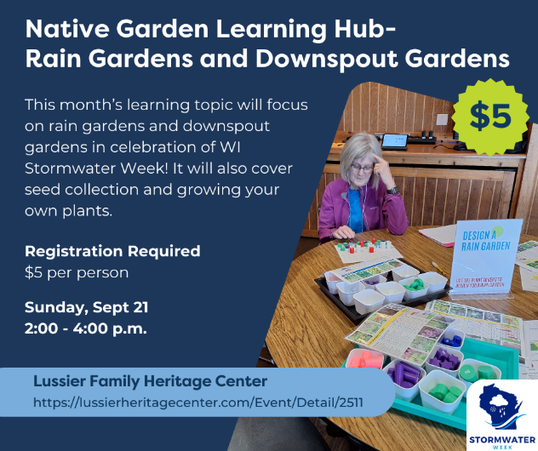

Planting a rain garden or downspout garden is a great way to prevent stormwater runoff and protect our waters. Join us at this month’s Native Garden Learning Hub Gathering to get your questions answered. Planting plans and resources will be available and experts will be on hand to provide design help. *#WIStormwaterWeek #WIRippleEffects #RainGardensRock #DownspoutGardensRock*

Register at: [*www.ripple-effects.com/wi-stormwater-week*](http://www.ripple-effects.com/wi-stormwater-week)

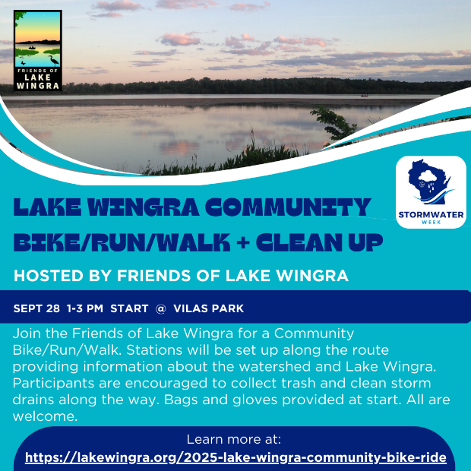

The Lake Wingra Community Bike/Run/Walk + Clean Up is fun, free opportunity to learn all about Lake Wingra watershed while taking action to keep it clean! Make sure to pick up supplies at the start and collect trash and clear storm drains on the route. Stop by the Wingra Park station, grab some free ice cream and check out the rainfall simulator demo too.

*#WIStormwaterWeek #WIRippleEffects*

Learn more at: [*www.ripple-effects.com/wi-stormwater-week*](http://www.ripple-effects.com/wi-stormwater-week)

**Additional graphics will be provided in early Sept. to promote webinars during WI Stormwater Week**